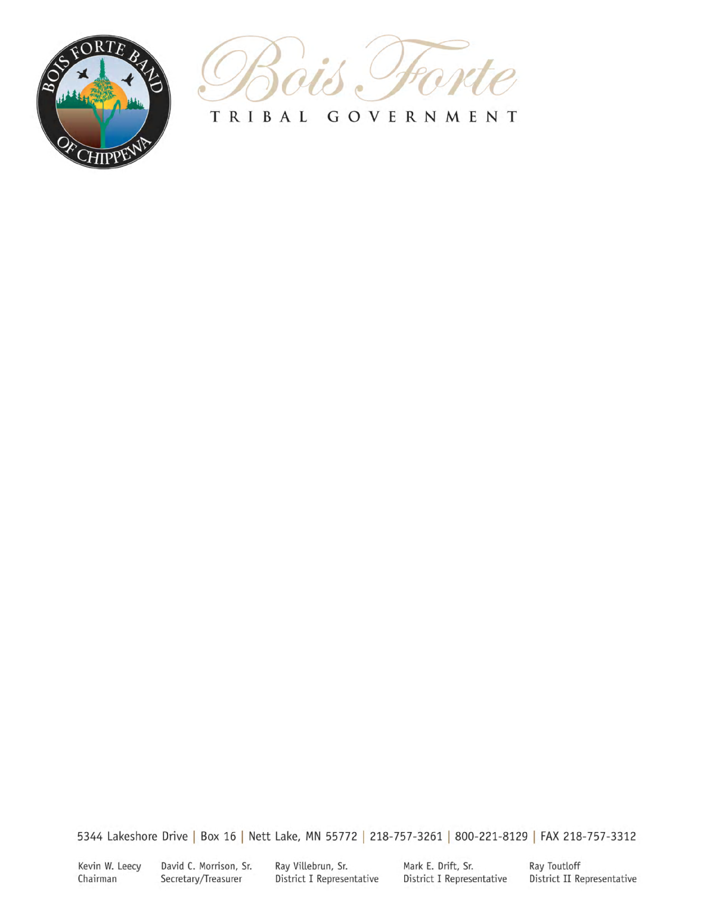**Bois Forte Scholarship Program Policies**

A. Purpose. The purpose of this policy is to establish eligibility criteria and other requirements associated with financial assistance provided by the Bois Forte Band to meet the cost of attendance at an institution of higher education.

B. Definitions: As used in this policy, the following terms shall have the meaning set forth below:

1. “Student” means a person who is enrolled at least three (3) credits per quarter or semester, or the equivalent, in a program or course of study that applies to a degree, diploma, or certificate.

2. “Full-time” means enrollment in a minimum of 12 credits per quarter or semester, or the equivalent.

3. “Cost of attendance” means the tuition, fees, books, and costs of attending school, as defined by federal law, including 20 U.S.C. § 1087 ll of the Higher Education Act.

4. “Part-time” means less than full time enrollment as a student.

5. “Education plan” means a written synopsis describing the degree, diploma or certificate

sought, a list of courses and credits completed, and a list of courses and credits required for completion. In the event a student is required under paragraph F.5 and/or G.3 to submit an education plan, a narrative describing a student’s plan to achieve his or her educational objectives along with the written approval or concurrence of the guidance counselor must be part of the plan.

1. ”Eligible courses” means courses taken from institutions of higher education providing

college or technical college credit for completed courses. On-line courses will only be considered if the course(s) is required for the degree and/ or graduation requirements.

1. “Ineligible Courses” means courses not offered from an accredited institution: community education courses, professional development courses, private companies and professional organizations offering training.
2. “Short term courses” means eligible courses, as defined above, which are less than one (1) year in duration and prepares the student for gainful employment in a recognized occupation listed in the “occupational division” of the latest edition of the Dictionary of Occupational Titles, published by the U.S. Department of Labor.
3. “Student agreement” means the form used by the Education Division that serves as documentation that the policies and procedures were provided to the student; the act of signing this form by the student means the student understands and agrees to abide by the policies and procedures of the Bois Forte Education Scholarship Program.
4. “Direct School Costs” means the cost of institution tuition and related fees, books, and supplies/uniforms as required for the program. It may also include an allowance for transportation as determined by the institution of attendance.
5. “High income” means those students who have been considered ineligible for Federal and State student aid due to parental and/or student income guidelines.
6. “Good-faith effort” means a sincere attempt was made to by the student to remain in school. It may be demonstrated by submitting a personal letter from the student explaining the reason for leaving school or the failure to meet satisfactory academic progress. In most cases, it will be required to submit documentation from someone the student has been in contact with concerning the reason for leaving school. Examples include, but not limited to, the student’s academic advisor and/or representative of the institution; the student’s physician or other professional person familiar with the student’s situation explaining the reason for leaving school.

C. Eligibility. Applications for financial assistance may be filed by persons who:

1. Are enrolled members of the Bois Forte Band of Chippewa Indians, and who have completed the Bois Forte Scholarship Application; and

2. Have been accepted at an institution of higher education (as defined by applicable federal law); and

3. Have completed a Free Application for Federal Student Aid (FAFSA) form; and

1. Students registered for less than six credits or students taking short-term courses, as

defined in paragraph B.7, or students enrolled in an eligible course that does not qualify

for federal or state financial assistance do not need to complete the ISAP. A request

for the students direct school costs from the Bois Forte Education Division will replace

the ISAP.

4. Have completed the Minnesota Indian Scholarship Application (ISAP) form or the equivalent form, if any, from another state; and

5. Have completed, if applicable, the Bois Forte out-of-state application form; and

6. Have applied for financial assistance from all other available sources, including but not limited to public and private grants and scholarships; and

7. Are not in default of any tribal, federal, or state student educational loan; and

8. Are not ineligible for any other tribal, state, or federal grant or scholarship by reason of non-compliance with child support payments, as provided in state, tribal, or federal law.

D. Applications

1. Completed applications, including all documents required by paragraph E, below, may be filed after January 1. Applicants are encouraged to file applications prior to July 1 each year. Failure to do so may result in a denial of funding, a delay in funding, or being placed on a waiting list, as described in D. 3.

2. Applications will be reviewed and financial assistance awarded on a first come, first served basis until available funding for the current academic year has been exhausted.

1. In the event the program funding for the current academic year becomes exhausted, notification letters will be sent to all students who have a complete~~d~~ scholarship file with the Bois Forte Scholarship Program. These students will be placed on a waiting list according to the date their scholarship file was complete. In the event funding becomes available , students will be awarded according to the waiting list for the current academic year.
2. All students must complete the financial aid process in its entirety each year they plan to attend college. No priority will be given to returning students or students placed on the waiting list of the prior academic year.

E. Required Documentation. The following documents must accompany the student’s file each

year prior to award determination.

1. Bois Forte Scholarship Application; and

1. A copy of grade reports or transcripts from the previous term of attendance (if applicable); and
2. If applicable (see paragraph C. 4), a complete Minnesota Indian Scholarship Assistance Program (ISAP) student budget, or the equivalent form (if out-of-state) with the needs analysis section completed and signed by a financial aid office representative; and
3. An education plan, as defined in paragraph B.5, will be required by students placed on financial aid probation or suspension with the Bois Forte Scholarship Program. It is recommended that all students complete an education plan for personal reference to be used as a tool when selecting future courses.

1. A signed student agreement must be on file.

F. Satisfactory Academic Progress

1. Recipients of financial assistance must meet the following requirements for each term funded by the Bois Forte Scholarship program in order to remain eligible for continuing assistance:

a. At the end of each grading period, the student must have a grade point average of C or its equivalent, or academic standing consistent with the institution’s requirements; and

b. The student must complete twelve (12) credits per term (full-time students); or

c. The student must complete the number of credits for which enrolled (part-time students).

2. Failure to maintain satisfactory academic progress, as described in paragraph F. 1, above, will result in financial aid probation – to the effect that the student must achieve satisfactory academic progress by the end of the grading period following that in which he or she failed to make satisfactory progress.

1. Failure to achieve satisfactory academic progress during the probationary period may result in financial aid suspension; the student being ineligible for further Bois Forte financial assistance until the student demonstrates satisfactory academic progress.

a. An extension of financial aid probation may be granted provided good-faith effort has been demonstrated, as defined in paragraph B.11.

b. An extension of financial aid probation may be granted for incomplete grades provided

documentation from the professor of the incomplete course and/or advisor that the

student and the professor are working cooperatively to get the coursework completed.

c. For students taking a course that spans the period of one semester, financial aid probation for an incomplete grade may not be applied provided documentation from the professor and/or advisor is received.

4. A student placed on financial aid probation or suspension by the Bois Forte Scholarship Program may use the following term for which Bois Forte does not provide financial assistance as a basis for relief from financial aid probation or suspension provided that satisfactory academic progress as defined in paragraph F.1 has been achieved to place the student in good academic standing with the Bois Forte Scholarship Program.

5. Students must submit grades following each grading period. Failure to submit grades will: (1) delay funding for next term until grades are received by the Education Department; and (2) be considered a failure to make satisfactory academic progress.

G. Failure to Complete

1. Students who leave schools for any reasons (withdraw, dropped from the rolls, or other reason) may be subject to a reduction of subsequent funding in the event the student returns to school. Financial assistance may be reduced if circumstances demonstrate that prior to leaving school the student failed to make a good faith effort as defined in paragraph B.11

2. Students who have received a grade of incomplete may be considered having failed to make satisfactory academic progress as defined in paragraph F. Upon written notification of course completion from the institution, the student’s status may be rescinded; provided the probation or suspension was a direct consequence of the incomplete coursework in question; and further provided that the final grades for the term meets the satisfactory academic progress policy defined in paragraph F.

3. Upon application following a period during which a student left school, the student may be required to submit an education plan as a condition of financial assistance.

H. Limitations on Financial Assistance

1. ALL Financial assistance is subject to the availability of funds for such purposes.

1. Financial assistance grants are for the purpose of paying the cost of attendance at eligible institutions.
2. Educational financial assistance will only be provided for eligible courses as defined in paragraph B.6, below.

3. Students attending less than full-time will be provided assistance for direct school costs only, as defined in paragraph B.9.

4. Financial assistance for short-term course will be limited to direct school costs, as defined in paragraph B.9.

5. Testing fees will be provided once per academic year per student per program.

6. Full-time students may receive financial assistance from the Bois Forte Band unless the student has previously been provided financial assistance from the Bois Forte Scholarship Program for full-time enrollment (or the equivalent) for ten (10) semesters or fifteen (15) quarters provided, that applicants pursuing a second four-year degree are eligible to receive funding if funds are available; and provided further, that students who have been enrolled for a number of semesters or quarters greater than that normally required to obtain the degree sought may be required to submit an education plan and/or be on financial aid probation as a condition of assistance. For purposes of this paragraph semesters or quarters (full time or equivalent) completed prior to April 2, 1999 and funded by Bois Forte will not be counted.

7. Graduate students are eligible to receive funding subject to the maximum amount set forth in paragraph H.9, below, provided that funds are available.

8. Students will be eligible for financial assistance for summer session provided the courses taken are prerequisites for fall term or will apply toward graduation requirements. Award will be based upon direct school costs and will not exceed the amount required for a zero balance as reflected on a current student statement and/or $3,000.00, whichever is less.

9. The policy of the Education Division is to maximize the amount of financial assistance from other sources. The maximum amount of assistance from the Bois Forte Band shall be $5,000.00 per school year for undergraduate students, and $7,500.00 per school year for graduate students.

1. The maximum amount of funding per quarter/semester will not exceed 50% of the annual maximum award limitation for any student status.
2. The Bois Forte Reservation Tribal Council and the Bois Forte Education Division **will not** be responsible for educational student loans under any circumstances.
3. Financial assistance will not be provided for previous terms of attendance, unless the student still owes money to that school for a previous term of attendance as demonstrated by a current student statement, provided the maximum allowance for that school year has not been reached. Assistance shall only be made payable to the institution, and will not include lawyer fees, administration fees, or any fees associated with the collection process.

I. Funding Determinations/Recovery of Over-Payments

1. Initial determinations of financial assistance will be based on the demonstrated need of the student as determined by the student’s Indian Scholarship Assistance Program (ISAP) application to meet the costs of attendance subject to the maximum amount set forth in paragraph H.9 above; the needs analysis will be prepared by a financial aid office representative at the institution the student is attending.

a. Students who have been considered “high income” may be awarded a maximum of $7,500.00 for undergraduate students, and $8,750.00 for graduate students (excluding summer session limitation set forth in paragraph H.8. above).

b. Students who are ineligible for other federal and state aid due to the number of registered credits may be awarded a maximum of $3,750.00 per semester/quarter, and shall not exceed the maximum $7,500.00 per academic year (excluding summer session limitation set forth in paragraph H.8. above). Funding will be based upon direct school costs only.

2. The policy of the Education Division is to award financial assistance fairly and impartially. Complete applications will be date and time stamped upon receipt, and a separate log maintained to identify the order in which applications are received.

3. In the event a student has been over-awarded in any term, the amount may be recovered by reducing subsequent awards following notice and explanation to the student of the reason for the action, including a revised ISAP if appropriate. An over-award for a term which is the final term for which Bois Forte financial assistance is received or sought may be recovered by other means prescribed by the Commissioner of Education, provided that the student will in all cases be given notice of a proposed recovery.

J. Appeals

1. Applicants denied assistance or otherwise aggrieved by a decision may appeal to the Commissioner of Education. An appeal must be (1) written; (2) filed within ten (10) business days of receipt of the decision from which the appeal is taken; (3) include a statement of reasons why the decision is in error; and (4) specify the relief sought by the applicant; and (5) attach appropriate documentation signed by a professional staff person who is familiar with your situation and is willing to advocate on your behalf, if requested.

2. The Commissioner of Education may affirm, reverse, modify, or condition the decision which is being appealed.

3. Decisions of the Commissioner of Education shall be in writing and made within ten (10) business days of the date of receipt of the appeal.

1. Decisions of the Commissioner of Education are subject to the review of the Reservation Tribal Council, and its decision shall be final. A request for RTC review shall be written and filed with the Executive Director no later than five (5) days after the receipt of the Commissioner of Education’s decision.

For additional information or questions, please contact the Education Office:

Bois Forte Tribal Government Phone: (218) 757 - 3124

Department of Education Fax: (218) 757 - 3126

PO Box 16 www.boisforte.com

Nett Lake, MN 55772 for current email address

**Bois Forte Scholarship Program**

**Student Agreement**

I, , the student, have read and understand the Policies of the Bois Forte Scholarship Program, I agree to abide by all Policies governing the Bois Forte Scholarship Program.

I understand that my negligence towards these policies and application criteria may jeopardize my current and/or future student status and overall eligibility with the Bois Forte Scholarship Program.

I understand that should my academic performance be less than the minimum Satisfactory Academic Progress requirements of the Bois Forte Scholarship Program, I risk probation and/or suspension from the Bois Forte Scholarship Program.

I understand that it is my responsibility to submit my grades and/or transcripts at the end of each term of attendance for which I received educational financial assistance from the Bois Forte Scholarship Program.

I agree to take full responsibility for my academic achievements and progress as well as all costs incurred relating to my academic career beyond the amount I may be awarded by the Bois Forte Scholarship Program.

I will be attending the during the

Institution Attending

academic year.

Student Signature