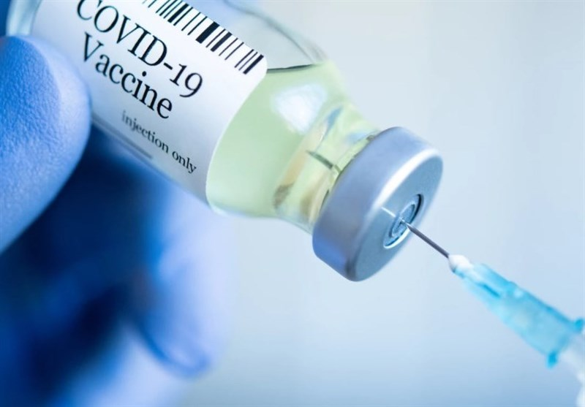
MODERNA VACCINE IS AVAILABLE For Ages 18 and older
THE COVID-19 VACCINE
IS AVAILABLE AT BOTH
BOIS FORTE MEDICAL CLINICS!
If you are interested in getting the COVID-19 vaccine; you must be a tribal member, and must live in St. Louis, Koochiching, or Itasca Counties.
Please call one of the Bois Forte Clinics to get on a Call-Back List for scheduling.
An allotment of the COVID-19 Moderna Vaccine is shipped to both clinics on a week by week basis based on availability from IHS.
Vaccine Inventory is subject to change weekly so please be patient !!!
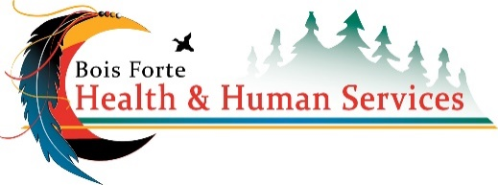
VACCINE PROTOCOL:
AT THE CLINIC:
- Plan on arriving 10-15 minutes early to complete the required forms
- Get called into a room for your appointment:
  - Your temperature is taken
  - Forms containing information on the Vaccine you are receiving will be given to you.
  - You will receive the Vaccine.
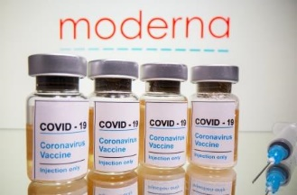
  - You will receive your COVID-19 Vaccination Card
AFTER YOUR APPOINTMENT:
- Remain in the lobby for 15 minutes for monitoring.
- Schedule your follow up appointment at the front desk for your second dose.
AT HOME:
- Sign up ,using your smart phone, for V-SAFE through the CDC, instructions will
be provided. This is NOT MANDATORY!

NETT LAKE CLINIC SCHEDULING:
218-757-3650
VERMILION CLINIC SCHEDULING:
218-753-2182

