**REQUEST FOR PUBLIC COMMENTS**
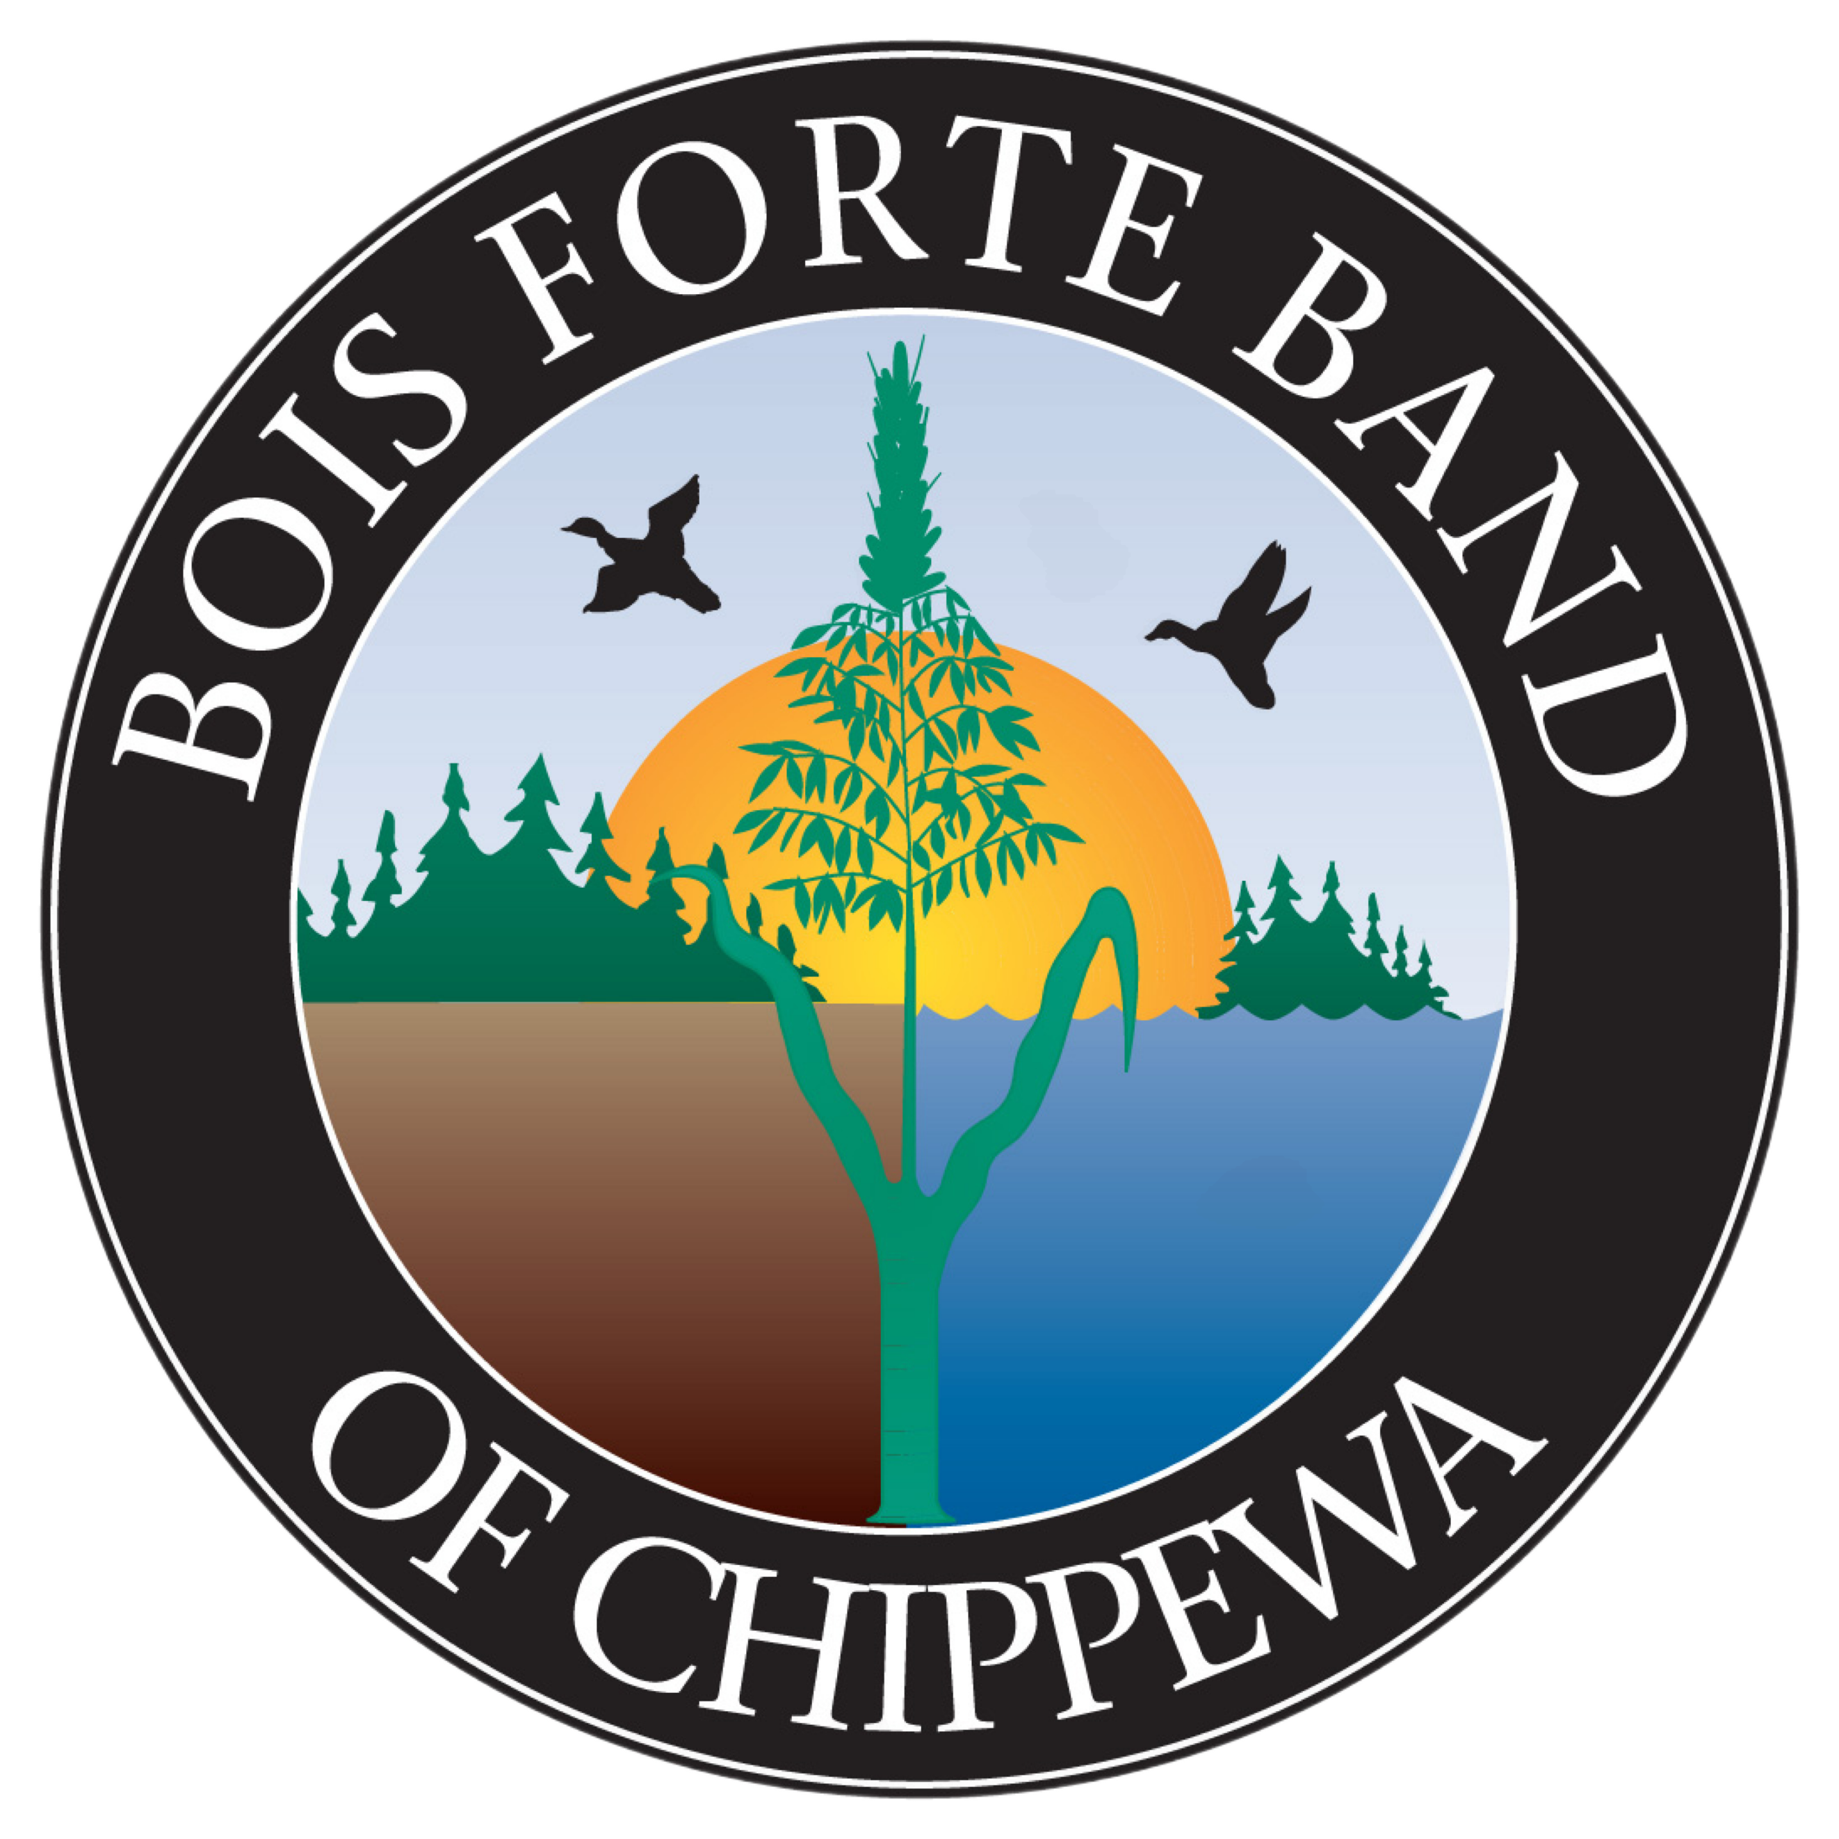

To: Bois Forte Tribal Members
Bois Forte Tribal Government Departments
From: Bois Forte Reservation Energy Department

Re: Seeking Comments on Proposed site for a Solar Farm on Vermilion Sector
Date: January 17, 2025
The Bois Forte Energy Department is currently seeking comments from Bois Forte members and Bois Forte Tribal Government Departments and employees on the proposed site for a solar farm location in the Vermilion sector. Please submit any comments or questions to Executive Assistant, Bois Forte Tribal Government, via email (executiveassistant@boisforte-nsn.gov OR https://portal.laserfiche.com/u7744/forms/solarfarmproject ) or mail at 5344 Lakeshore Drive, Nett Lake, MN 55772 no later than February 20, 2025.
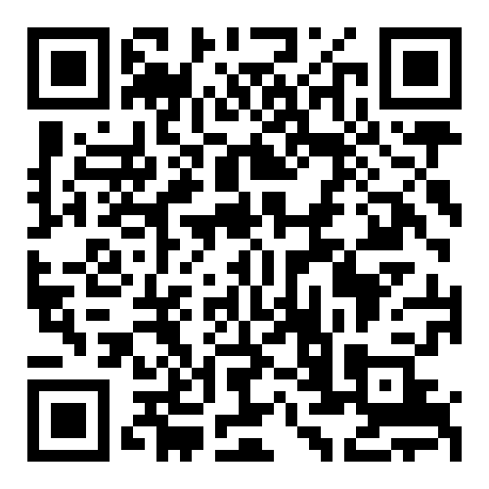TO SUBMIT COMMENT
Project Information:
In September 2024, The U.S. Department of Interior awarded Bois Forte funding for their grant application to build a solar farm to offset energy costs for Bois Forte members.
The project will require 8 to 14 acres of land to build the 2 MW solar farm project. The proposed project site has 28-acres that we would explore for feasibility and design of the solar farm project. Please see the proposed project site location with the Y-Store location as a reference point.
We welcome your comments and questions for the proposed project site.
